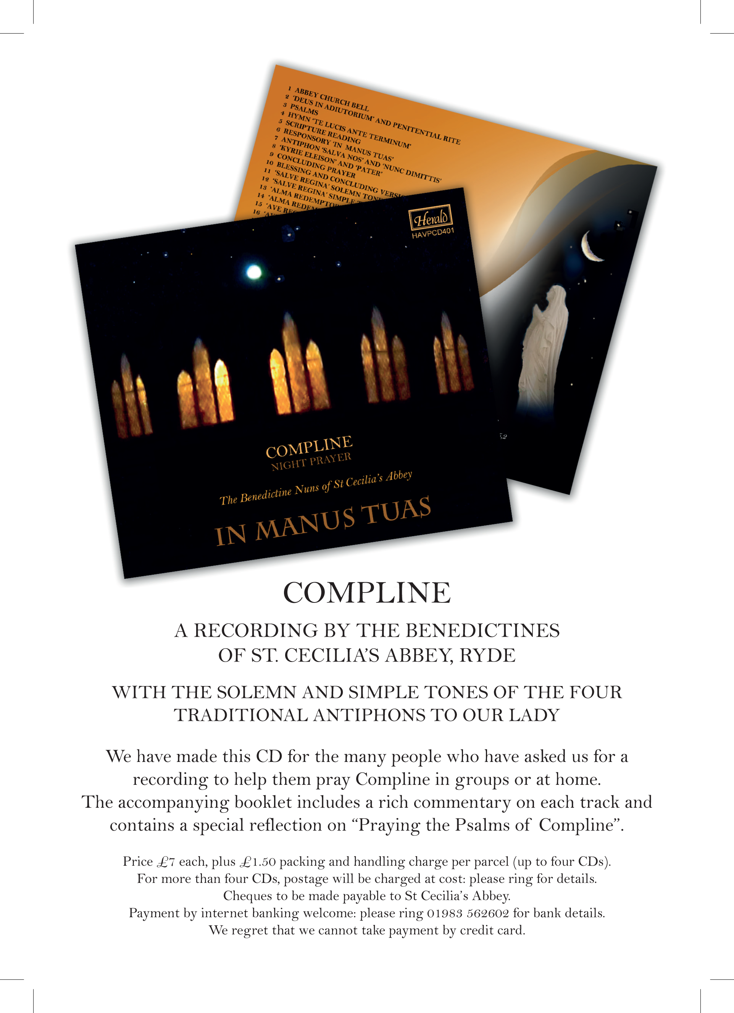
our latest recording: made in 2017
St. Cecilia’s Abbey · Ryde · Isle of Wight
PO33 1LH

Tel 01983 562602
Email bursar@stceciliasabbey.org.uk
Registered Charity 1088086
VAT Reg No 108618766

Compact Disc Recordings of Gregorian Chant

 |  | £
1 | Corpus Christi  – in honour of the Eucharist | 12.50
2 | Gaudete  – selections from the liturgical year | 12.00
3 | Magnificat  – in honour of Our Lady | 12.00
4 | Cantus Ecclesiae  – selections from the liturgical year | 8.50
5 | In Manus Tuas –  – Compline with antiphons to Our Lady | 8.50

All prices include UK postage.

Internet Banking preferred, please contact us for details.

Cheques should be made payable to St Cecilia’s Abbey

List updated in 2021
Recordings of Gregorian Chant
By the Benedictine Nuns of St Cecilia’s Abbey,
Ryde, Isle of Wight, PO33 1LH

1 | Corpus Christi – in honour of the Eucharist  Hymn: Pange lingua; Antiphon: Pater fidei nostræ; Offertory: Sanctificavit; Offertory: Sicut in holocausto; Communion: Panem de cælo; Communion: Panis quem ego; Antiphon: Ego sum panis vivus. Hymn: Venite Populi; Maundy Thursday:Introit: Nos autem; Tract: Ab ortu; Offertory: Ubi caritas; Communion: Hoc corpus; Hymn: Sacris Sollemniis; Organ Interlude: Tierce en Taille – Dandrieu; Mass of Corpus Christi: Introit: Cibavit eos; Gradual: Oculi; Alleluia: Caro mea; Sequence: Lauda Sion; Offertory: Portas cæli; Communion: Qui manducat; Organ: Choral Cistercien – Alain; Eucharistic Adoration: Hymns: Adoro te; Ave, Verbum incarnatum; O salutaris; Ave verum corpus; Tantum ergo; Bell; Divine Praises; Hymn: Te laudamus Domine; Organ Voluntary: Dialogue sur les grands jeux – De Grigny.
2 | Gaudete – selections from the liturgical year  Advent: Gaudete; O Emmanuel; Christmas: Hodie; Ecce nomen Domini; Epiphany: Illuminare; Hodie; Alma Redemptoris Mater; Lent:Sitientes; Miserere et Parce; Ave Regina Cælorum; Holy Week: Hosanna; Pueri Hebræorum; Nos autem; Lamentation of Jeremiah; Easter: Angelus Domini; Regina cæli; Ascension: Omnes gentes; Pentecost: Iam Christus astra ascenderat; Corpus Christi: Panis angelicus; Homo quidam; Ecce panis angelorum; Ordinary time: Inclina; Ecce iam noctis; Liturgy of the Dead: Domine Iesu Christe; In paradisum; Chorus angelorum; Salve Regina; Christ the King: Te sæculorum principem.

3 | Magnificat – in honour of Our Lady  Mass of the Immaculate Conception, 8th December: Introit: Gaudens; Gradual: Benedicta; Alleluia: Tota pulchra; Offertory: Ave Maria; Communion: Gloriosa; Hymn: Virgo Dei Genetrix; Ave Maria; Memorare; St Bernard: Sermon; Responsory; Sancta; Offertory: Recordare; Sub tuum; Alma  Mass of the Assumption, 15th August: Introit: Signum Magnum; Alleluia: Assumpta Est; Offertory: Assumpta Est; Communion: Beatum; Hymn: O Quam Glorifica; Antiphon: Virgo Prudentissima; Litany of the Blessed Virgin Mary; Antiphon: Ave Regina Cælorum;
4 | Cantus Ecclesiae – selections from the liturgical year  Missa de angelis; Kyrie, Gloria, Sanctus, Agnus Dei; Hymn: Gloria laus; Gradual: Bonum est; Alleluia: Veni Sancte Spiritus; Offertory: Stetit angelus; Hymns: Veni Creator; Te Deum.
5 | In Manus Tuas – Compline  Abbey Church Bell; Deus in adiutorium and penitential rite; Psalms; Hymn Te lucis ante terminum; Scripture reading; Responsory In manus tuas; Antiphon Salva nos and Nunc Dimittis; Kyrie Eleison and Pater; Concluding Prayer; Blessing and Concluding Versicle; Salve Regina Solemn Tone; Salve Regina Simple Tone; Alma Redemptoris Mater Solemn Tone; Alma Redemptoris Mater Simple Tone; Ave Regina Cælorum Solemn Tone; Ave Regina Cælorum Simple Tone; Paschaltide Hymn Jesu Redemptor Sæculi; Paschaltide Responsory; Regina Cæli Solemn Tone; Regina Cæli Simple Tone.

